Stats for Graphs
Put Excel files from David in P: drive under Statistics
1) Turn on Neil’s Mac
2) Open folder in P: drive with Excel files
3) Open first Excel file
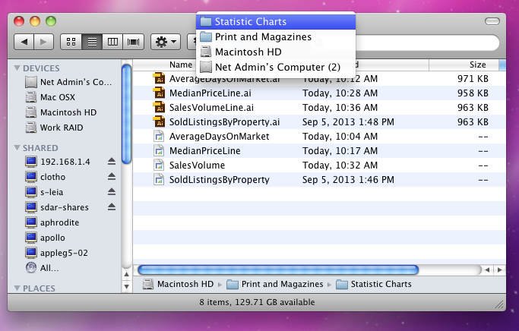
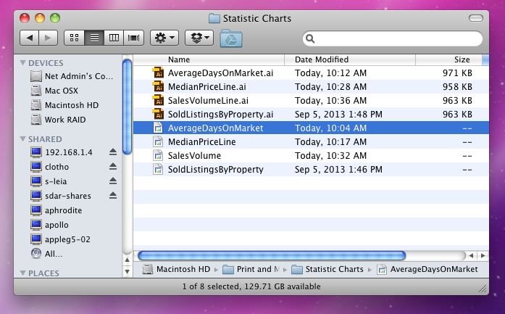
4) On Mac desktop – Click on MacIntosh HD – Go to Print & Magazines – Go to Statistic Charts

5) Open Excel file and corresponding “Numbers” file (not Illustrator) under Statistic Charts
6) On Excel file, select 3 columns minus the year – Right click and copy

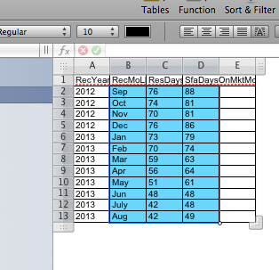
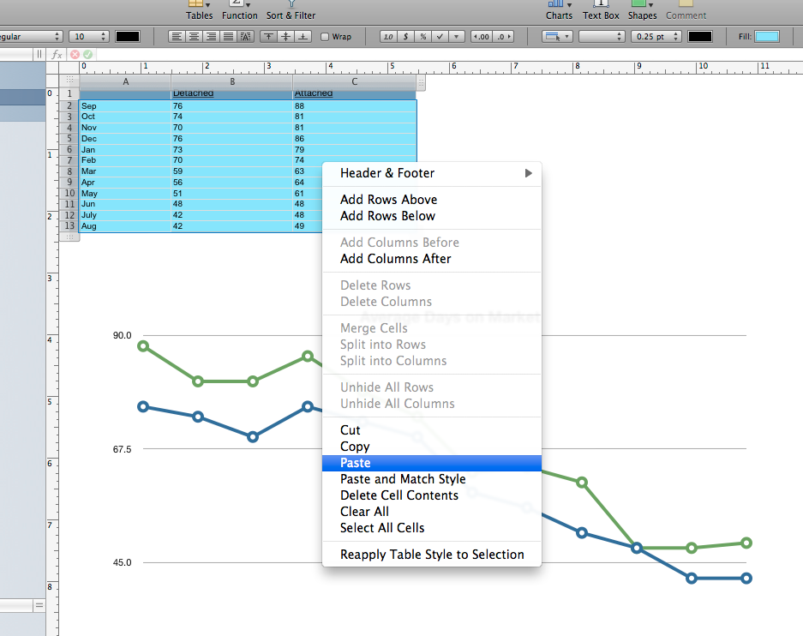
7) Paste onto “number” file – Save

8) Right click on file just saved – Go to Show Package Contents – Open Quick Look

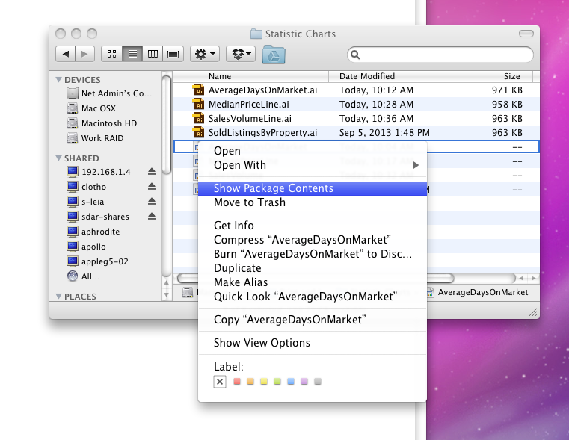
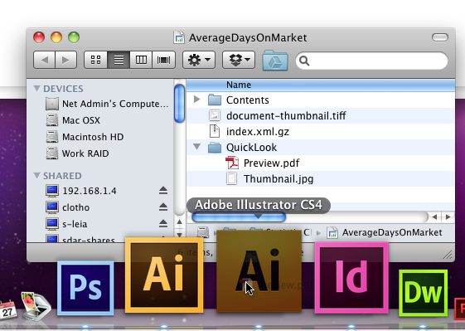

9) Drag Preview to Illustrator 4 icon on bottom (all yellow)

10) Double click on corresponding Illustrator file
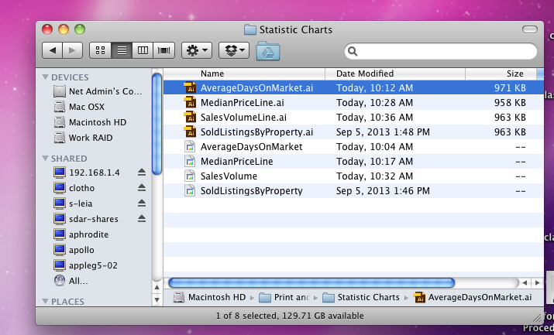
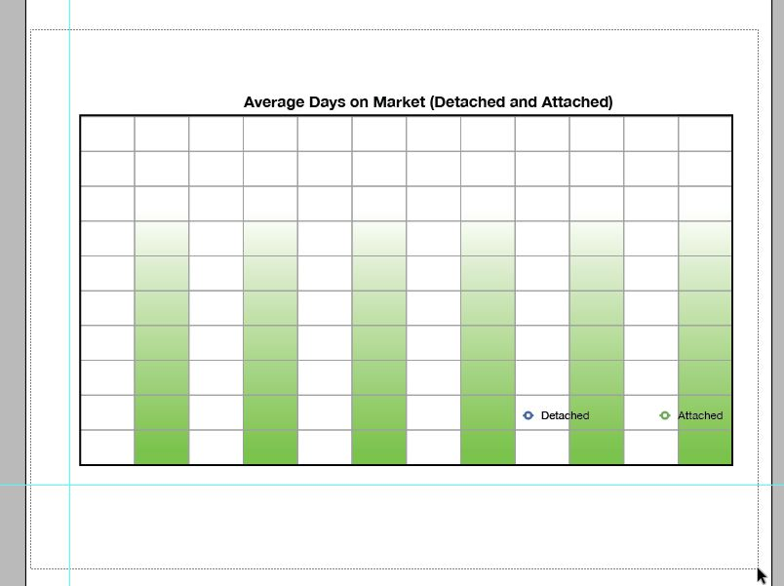
11) Drag box around full chart on Illustrator file and hit Delete.

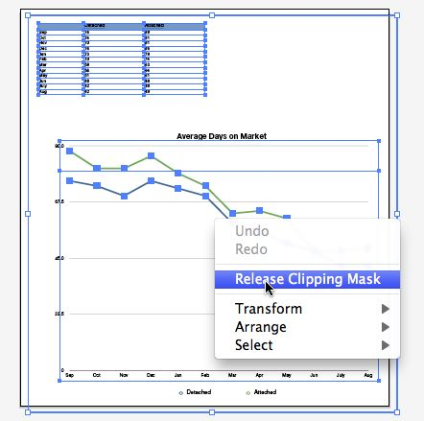
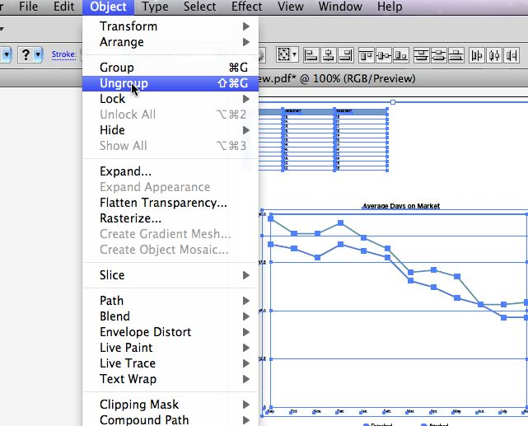
12) Go back to Preview – Select everything with box – Right click – Release Clipping Mask

13) Go up to “Object” on top row – Click Ungroup

14) Selectively delete all but the graph lines and numbers, including the zero
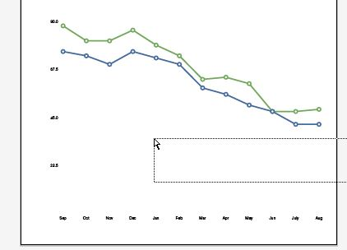
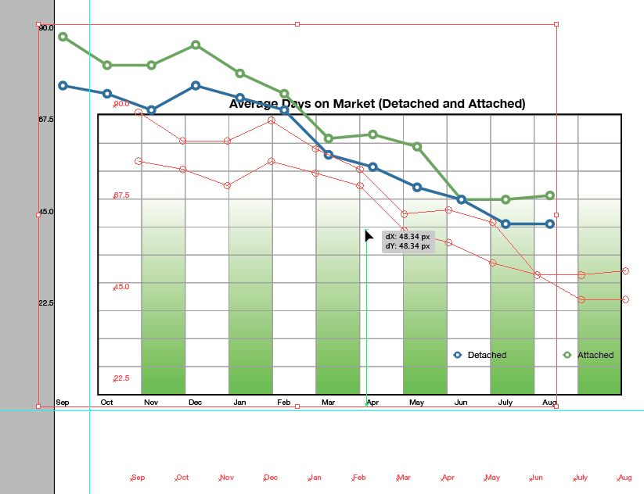
Select all with a box

15) Drag to chart window
Move graph lines to middle of chart

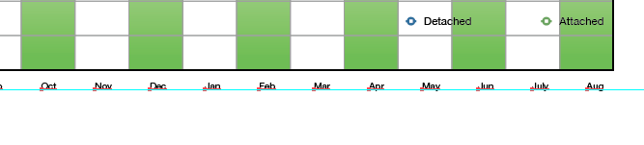
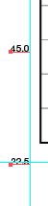
- Select months with a box and move up to just above blue guideline
- Select left axis and line up

18)Save first file.

